**Building Your First Castle with Git: A Step-by-Step Guide**

Imagine you're an architect about to embark on a grand castle project. But before you start laying bricks (writing code), you need a sturdy foundation and a well-organized way to track your progress. That's where Git comes in – your trusty toolbox for version control in the digital realm.

**Gathering Your Tools (Installing Git):**

First things first, you need the right tools for the job. Head over to <https://git-scm.com/downloads> and download Git for your operating system. It's like acquiring the building blocks (software) to manage your castle's blueprints (code).

**Setting Up Your Architect's Workshop (Configuring Git):**

Every architect has their own style. Git allows you to personalize your workflow by setting up your user information. Run these commands in your terminal (command prompt):

>git config --global user.name "Pradeep"

>git config --global user.email [pradeep.s@thinkbridge.in](mailto:pradeep.s@thinkbridge.in)

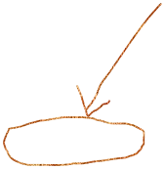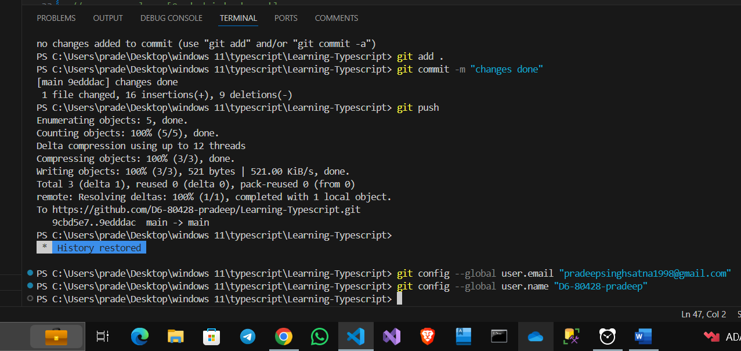

Think of this as engraving your name (username) and contact information (email) on your architect's tools (Git) so everyone knows who's building this magnificent castle (project).

**Laying the Foundation (Creating a Repository):**

Now it's time to claim your land and start building! Create a new folder for your project using the command:

>mkdir my_project

This is like creating the designated area where your castle (project) will reside. Next, navigate into that folder using:

>cd my_project

Finally, to officially mark the beginning of your project, initialize a Git repository within this folder using:

>git init

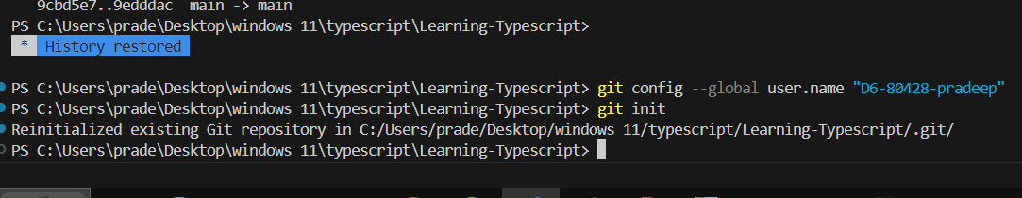

Imagine this as laying the foundation for your castle's archive (repository), where you'll store all the blueprints (code) and track its history (changes).

**Adding the First Brick (Creating a File):**

Every castle starts with a single brick. Let's create a basic file called "hello.txt" that says "Hello, Git!" using the following command:

This is like placing the first brick (file) in your construction zone (project).

**Preparing the Blueprint for Storage (Adding a File to Git):**

Before storing your brick (file) in the archive (repository), you need to tell Git about it. Use the git add command:

>git add index.html

>git add bluestylr.css

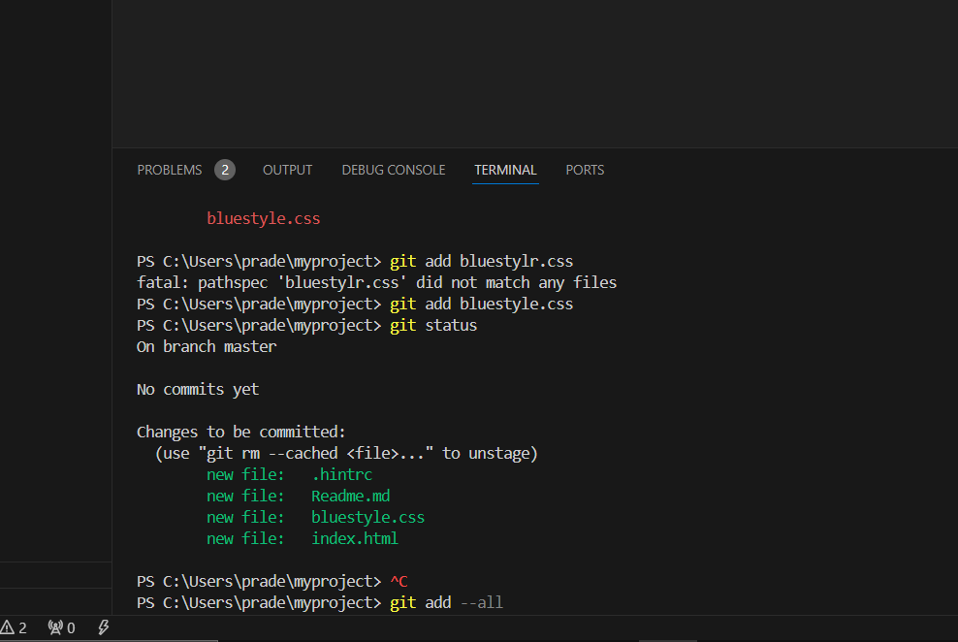

Think of this as selecting the brick (file) and marking it for storage in the castle's blueprint archive (repository).

**Saving Your Work (Committing Changes):**

Finally, to permanently save the current state of your project (including the "hello.txt" file), you need to commit it using:

>git commit -m "Initial commit"

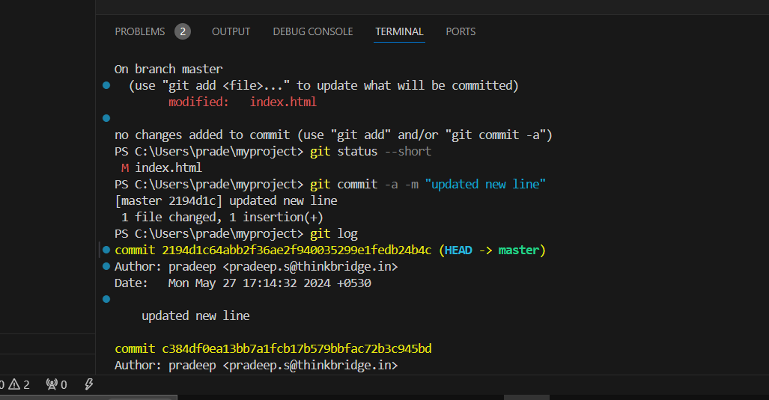

This is like taking a snapshot of your construction progress (commit) and labeling it with a descriptive message (like "Initial commit"). This message helps you understand the purpose of this particular commit in the future.

Congratulations! You've successfully set up Git on your machine, created your first repository, and committed your initial changes. Now you have a solid foundation for building your magnificent project, one commit (brick) at a time!